**ME 755 Senior Design**

**Fall 2019**

**Project/Research Statement and Design/Research Criteria**

**Team #3**

**Project Name**

The Development of a Hybrid Rocket

**Team Members:**

Silas Johnson (Operations Lead)

Lucas Simmonds (Avionics Lead)

Zach Raboin (Propulsion Lead)

Charlie Nitschelm (Propulsion)

Carly Benik (Avionics)

Darren Otten (Frame)

Nathan Gunter (Frame)

**Project Sponsor**

Contact name: Todd Gross

Contact email: [Todd.Gross@unh.edu](mailto:Todd.Gross@unh.edu)

Company name: UNH

**Faculty Advisor**

Todd Gross

**Project Statement:** The goal of this year’s project is to design, manufacture and fly a hybrid rocket to 10,000 feet as part of the Spaceport America Cup in June 2020. The ME team members will be primarily responsible for the development of the propulsion module (Runaway), the structural frame, airframe, and the mechanical side of recovery/payload. The main engineering objectives include achieve an apogee as close to 10,000 feet as possible, use of a simple research payload, full rocket recovery by dual deployment parachute strategies and live GPS tracking. The breakdown of the engineering team (consists of ME, EE, CS and PE) is detailed below in the graphics.

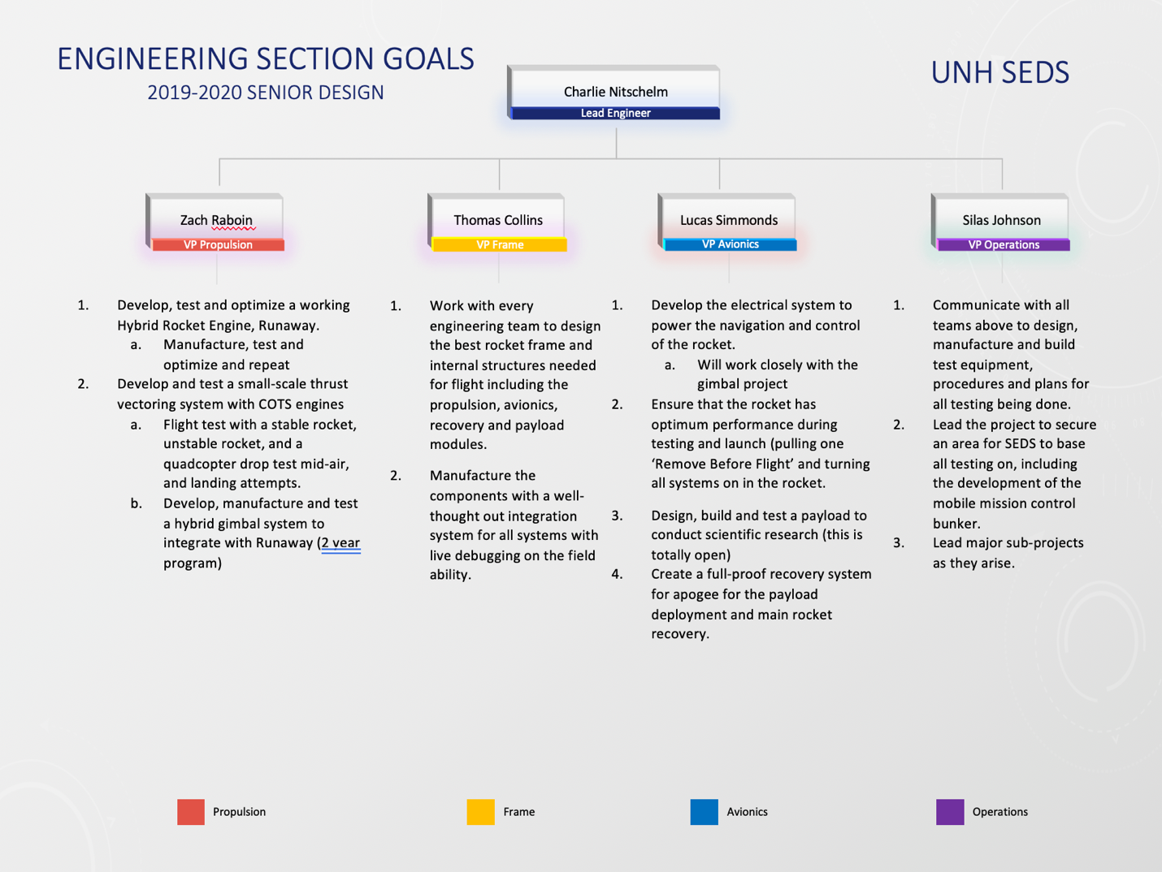

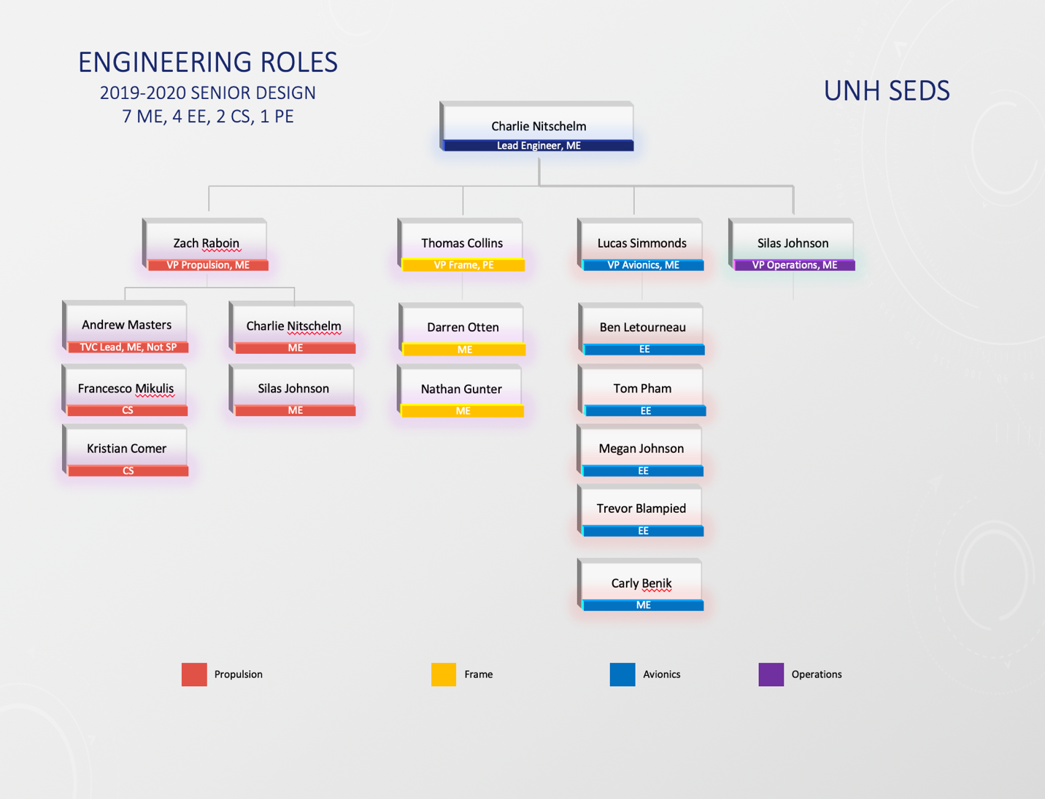

**Design Criteria:** Design/research constraints based on the project/research statement can help narrow down the possible design/research options.  See assignment document for additional detail.

Design Criteria Includes:

* Low-weight, factors in with propulsion data.
* Propulsion required to reach 10,000 feet for a given weight.
  + Points assigned based on proximity to this altitude. Points lost for going over 10K.
* Naturally stable, non-toxic propellants.
* Stable flight of the rocket, between 1 - 2 body calibers.
* Adhere to all Spaceport America Cup Design Requirements.
  + Launch rail exit velocity ( >50 m/s ).
  + Payload mass and volume requirements.
  + Ground Test Demonstration of Recovery System.
  + ...etc. see (<http://www.soundingrocket.org/sa-cup-documents--forms.html>) for full details.
* Ensure the safety of all operators and bystanders during testing, launch and manufacturing.
  + Safety critical wiring.
  + Redundant Electronics including separate power supply if primary system fails.
  + Pressure testing of combustion chamber (achieve FOS of 2).
  + Stability of rocket body in flight is stipulated.
  + Ability to empty oxidizer tank without passing through combustion chamber.
  + Two-factor arming of the vehicle ignition and all energetic (blackpowder, etc) devices.
* Adhere to all legal aspects of rocket launch, testing and design.
  + Specific approval required to utilize thrust vectoring modifications.
* Adhere to the strict timeline set out by the Spaceport America Cup.
* Ability to consistently retrieve the rocket and payload post-launch.
* Rocket is fully operational before May 2020 and able to launch at Spaceport America in New Mexico in June 2020.
  + Must be able to operate in the conditions of the New Mexico desert in June.
* Keep costs reasonable, fundraising required.
* Design and manufacture for the continuation of the project onto next year’s team

**Scope Changes**

* The airframe shell will no longer be composite, it will be cardboard to fit a standard size.
* The research payload will no longer be deployable, it will be a simple sensor in the payload bay.
* Changes to leadership structure, Zach Raboin is now propulsion lead, Carly Benik is on the Avionics team and Ross Thyne is no longer part of the team.
* Project design requirements have all remained the same.